Our Lady of Mt Carmel
Primary School
Mullewa

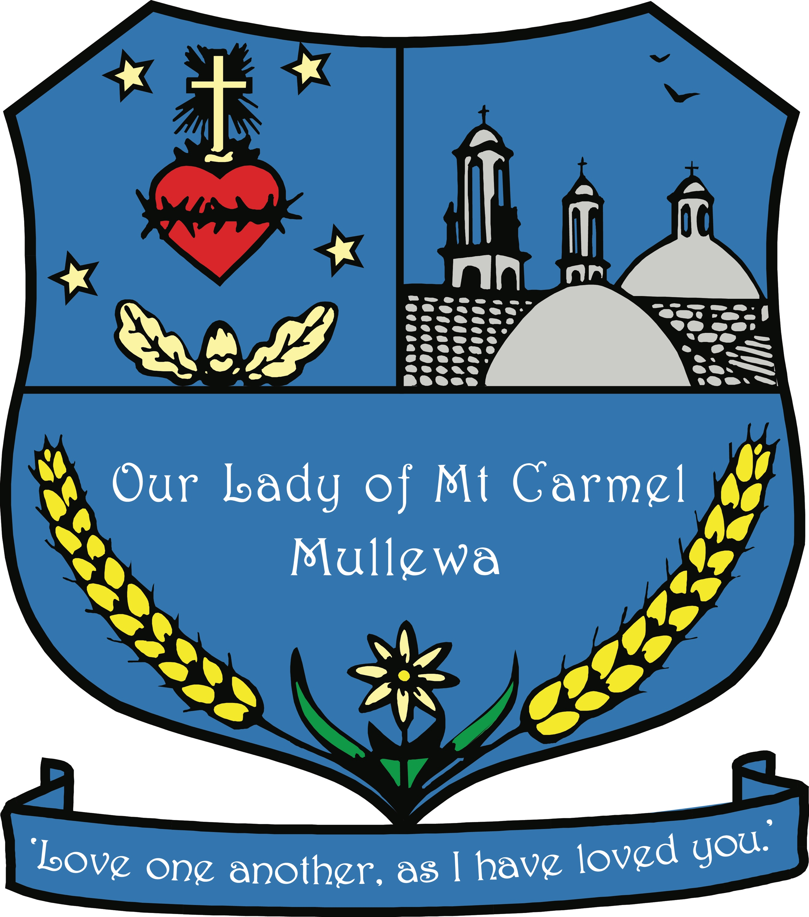

School Compliance Data
2024

System and Australian Government accountability regulations require that each school reports to its community on school performance in a number of key areas. The following information is a Commonwealth Government requirement and pertains to the 2024 calendar year.

Contextual Information
Our Lady of Mount Carmel School is situated in Mullewa, 472km north east of Perth and 100km east of Geraldton. The school was established in 1914 by the Presentation Sisters and their mission statement still continues to be relevant today. We are about developing an active faith community to 'Love one another as I have loved you' - our school motto. The school is a thriving co-educational school and caters for approximately 40 students from Kindergarten to Year 6. In the past, the majority of students have lived on farms and travelled to school by bus. This dynamic is changing as the school continues to enrol more students living in the Mullewa townsite, often from transient families. The school has strong links with the Parish. Parental involvement has been an integral part of the school life and it is through this that the School Board and the P&F Association are able to support the school in the areas of most need; involvement has begun to lessen as the number of families within the school continues to decline. The school is dedicated to developing the whole child, intellectually, physically, socially and emotionally, based on the Gospel values of the church, and more specifically the values of the Fruit of the Holy Spirit, taken from “Galatians” in the New Testament. The school motto of “Love one Another” stems from the founding Presentation Sisters who were originally the Sisters of the Sacred Heart of Jesus. The school’s crest envelopes the mission statement set by the Presentation Sisters;
‘With a pioneering spirit, Our Lady of Mount Carmel, Mullewa,
Aspires to foster Christian community
Living in harmony with each other and the environment.’

The entire staff, teaching and non-teaching are fully committed to providing the best possible Catholic education for the children in their care. Our whole staff are led by the belief that all students can learn, and that differentiated learning needs to occur across all learning areas, particularly in the areas of literacy and numeracy. As a professional learning community, the teaching staff have developed a set of whole school commitments for the teaching of literacy that have become embedded in the culture of the teaching and learning programs within the school. In 2024, the MaqLit program has continued within the senior classroom and elements of the Mini-Lit program have been introduced into the junior years and formal training has been completed for its implementation in the junior and middle years in 2025. Small group work programming and timetabling has continued to be maintained on a formal basis across the school during Literacy and Numeracy blocks with targeted levelling and instruction for all students. Each classroom is equipped with one to one iPads for students, and BenQ Boards, along with an Apple TV, are used in each classroom. These are supported through a strong network plus Wi-Fi for ease of connectivity. Each staff member has a device, with teaching staff having a MacBook or windows computer to assist in the area of preparation of lessons for the children, and Teacher Assistants an iPad, for use during small group instruction, and in order to provide a means for effective communication and collaboration at all times. Staff devices for both teachers and Teacher Assistants, especially iPads and large screens, are used as an important tool in carrying out the small group instruction that occurs across the school.

In 2024, staff continued to maintain relationships with outside agencies to support the school community; a strong relationship continues with our regional Catholic Education Office and their supporting consultants, along with the local Mullewa Police Force and the Mullewa District Office, as part of the City of Greater Geraldton. The school continues to endeavour to liaise with health agencies, particularly WA Country Health to ensure students are supported with Physiotherapy, Speech and Occupational Therapy referrals. Due to a lack of support services in these areas on a regular basis the school has worked tirelessly to set up its own Therapy program, along with a modern therapy room and resources, along with the appointment of staff (qualified Child Health Nurse) trained in assisting with student programs to ensure students receive the help they need to aid in their overall learning. In 2024, the school’s Health and Wellbeing Officer (a qualified registered nurse) continued to work within the complexities of the role, addressing the needs of students and liaising tirelessly to establish networks with outside agencies including WA Country Health, Western Australian Centre for Rural Health & University of Western Australia, Geraldton Regional Aboriginal Service, Child Health Services, Department of Communities and others.

School Characteristics

School Sector | Non-government
School Type | Primary
Year Range | K-6
Location | Remote
Total Enrolments Girls | 23
Total Enrolments Boys | 20
Indigenous Students | 35%
Language Background other than English | 2.3%
Student Attendance | 85%
Teaching Staff | 7
Full-time Equivalent Teaching Staff | 5.4
Non-teaching Staff | 7
Full-time Equivalent Non-teaching Staff | 4.65

Workforce Composition
Our Lady of Mt Carmel employed a total of 14 staff, 1 male and 13 female. There were 7 teaching staff and 8 non-teaching staff. There were 5.4 full-time equivalent teaching staff and 4.65 full-time equivalent non-teaching staff.

Teacher Qualifications
Our Lady of Mt Carmel employs 14 teaching staff. Collectively, the qualifications held by teachers, teacher assistants and the numbers who hold these qualifications are:
Certificates – 4
Bachelors – 9
Masters – 1
Doctorates – 1

Student Attendance
An average of 85% of students attended school each day in 2024.

Year Level | Attendance
PP | 79%
1 | 91%
2 | 85%
3
4 | 91%
5 | 79%
6 | 82%

Note on Attendance Data
Some of our attendance figures are disappointing due to the transient nature of some of families; students tend to travel with their families for extended periods of time. Figures appear to be influenced by specific students’ lack of attendance on a regular basis, rather than poor attendance by students in general. The school attempts to communicate with parents and families of those students who are regularly not attending school and implement positive approaches for encouraging students to attend school. The CEWA school psychologist is included in these approaches and practices where necessary. All relevant processes are followed and the school reports these absences to the relevant authorities, including both the Regional Office and the Department of Education.

Management of Non-Attendance
The school’s policies and practices are such that when a child is absent from school:
- The parent or caregiver is required to notify the school before 9am on the day of the absence
- Teachers complete attendance records on SEQTA by 9:15am each morning
- The office staff will send an ‘SMS’ notification to parents or caregiver if there is no recorded reason for a child’s absence
- If there is no response from the parent or caregiver after the initial contact, then if further investigation is required, this can possibly be managed by contacting other members listed by the family, or members of the community. The Principal will be notified if this is of concern
- Upon return to school, parents or caregiver will need to provide the school with a note to explain the reason for absence
- If there are prolonged periods of absence, less than 80% attendance, the Principal will make contact with the parents or caregiver to best support a stronger attendance pattern
- When the situation arises that a student has had a prolonged absence of fifteen days and when parents or caregiver cannot be contacted, then the support of outside agencies including the Catholic Education Office and possibly the Department of Child Protection will be involved to assist the school and family to address the situation

National Assessment Program – Literacy and Numeracy (NAPLAN) School Report
https://www.myschool.edu.au/school/48926/naplan

Parent, Teacher and Student Satisfaction

Parent Satisfaction
Our Lady of Mt Carmel has a strong community atmosphere and the support of the parent community is one of its strengths. Many of the students in our school are second or third generation students and are from families that have a vested interest in the school, in its position as an important part of the Mullewa community. Most parents, especially those with the means to, are supportive of assisting with school events and in their support of the Parents & Friends Association, particularly with regard to fundraising to support the purchase of extra resources for the students, and with assisting during Busy Bees and projects requiring labour so as to enhance the physical aspects of the school. Feedback from parents in an anecdotal sense, is that they have a high degree of satisfaction in the level of pastoral care. Until this point, the school has received very few complaints from parents with regard to their child’s learning and wellbeing. At enrolment interview, parents of students who are new to the town mention that the school has been recommended positively by local people within the town. Attempts have continued to be made to increase the level of parent understanding in terms of reading academic reports, and understanding a child’s level of academic achievement through the availability of teacher meeting with parents across each term, along with formal teacher/parent meetings twice a year. Due to the small number in our student population, the staff will continue to address any parent feedback received and ensure lines of communication remain open and supportive of listening to, and attending to parent concerns.

Teacher Satisfaction
Staff demonstrate a professional approach to all areas of the students’ education; Our Lady of Mount Carmel fosters a very collegial working environment. There is a high retention of staff which demonstrates the many quality relationships that exist between staff. Whilst there is turnover of graduate teachers, many of the staff are long serving members who demonstrate a sincere commitment to the ongoing performance of the school, and to the students in their care. Feedback gained from exit interviews with staff transient to Mullewa, tends to indicate this is due more to the lack of amenities in the town, rather than the school environment. A culture of professional respect, friendly cooperation and congeniality is evident within the school.

Student Satisfaction
Students at Our Lady of Mount Carmel Catholic Primary School work and play in a happy, safe and friendly environment There is a reported satisfactory level of student satisfaction based on the following:
• Minimal incidents of negative interaction amongst students both in and out of the classroom
• There is a strong level of engagement and progress in various learning programs, particularly differentiated small groupings
• Students show a high level of cooperation with staff
• There is consistent well documented progress from students
• The students are very inclusive of all nationalities
• The students exhibit a nurturing attitude towards each other
• There is a willingness to participate
• There is strong evidence of collaboration amongst students as noted by class teachers and other staff members.

Post School Destinations
Nagle Catholic College, Geraldton – 2
Mullewa District High School, Mullewa – 1
Geraldton Grammar, Geraldton - 1
Morawa District High School – 1
Meekatharra School of the Air - 1

SCHOOL INCOME
Detailed school income data can be accessed on the MySchools website.
Please see link below
https://www.myschool.edu.au/school/48926/finances

